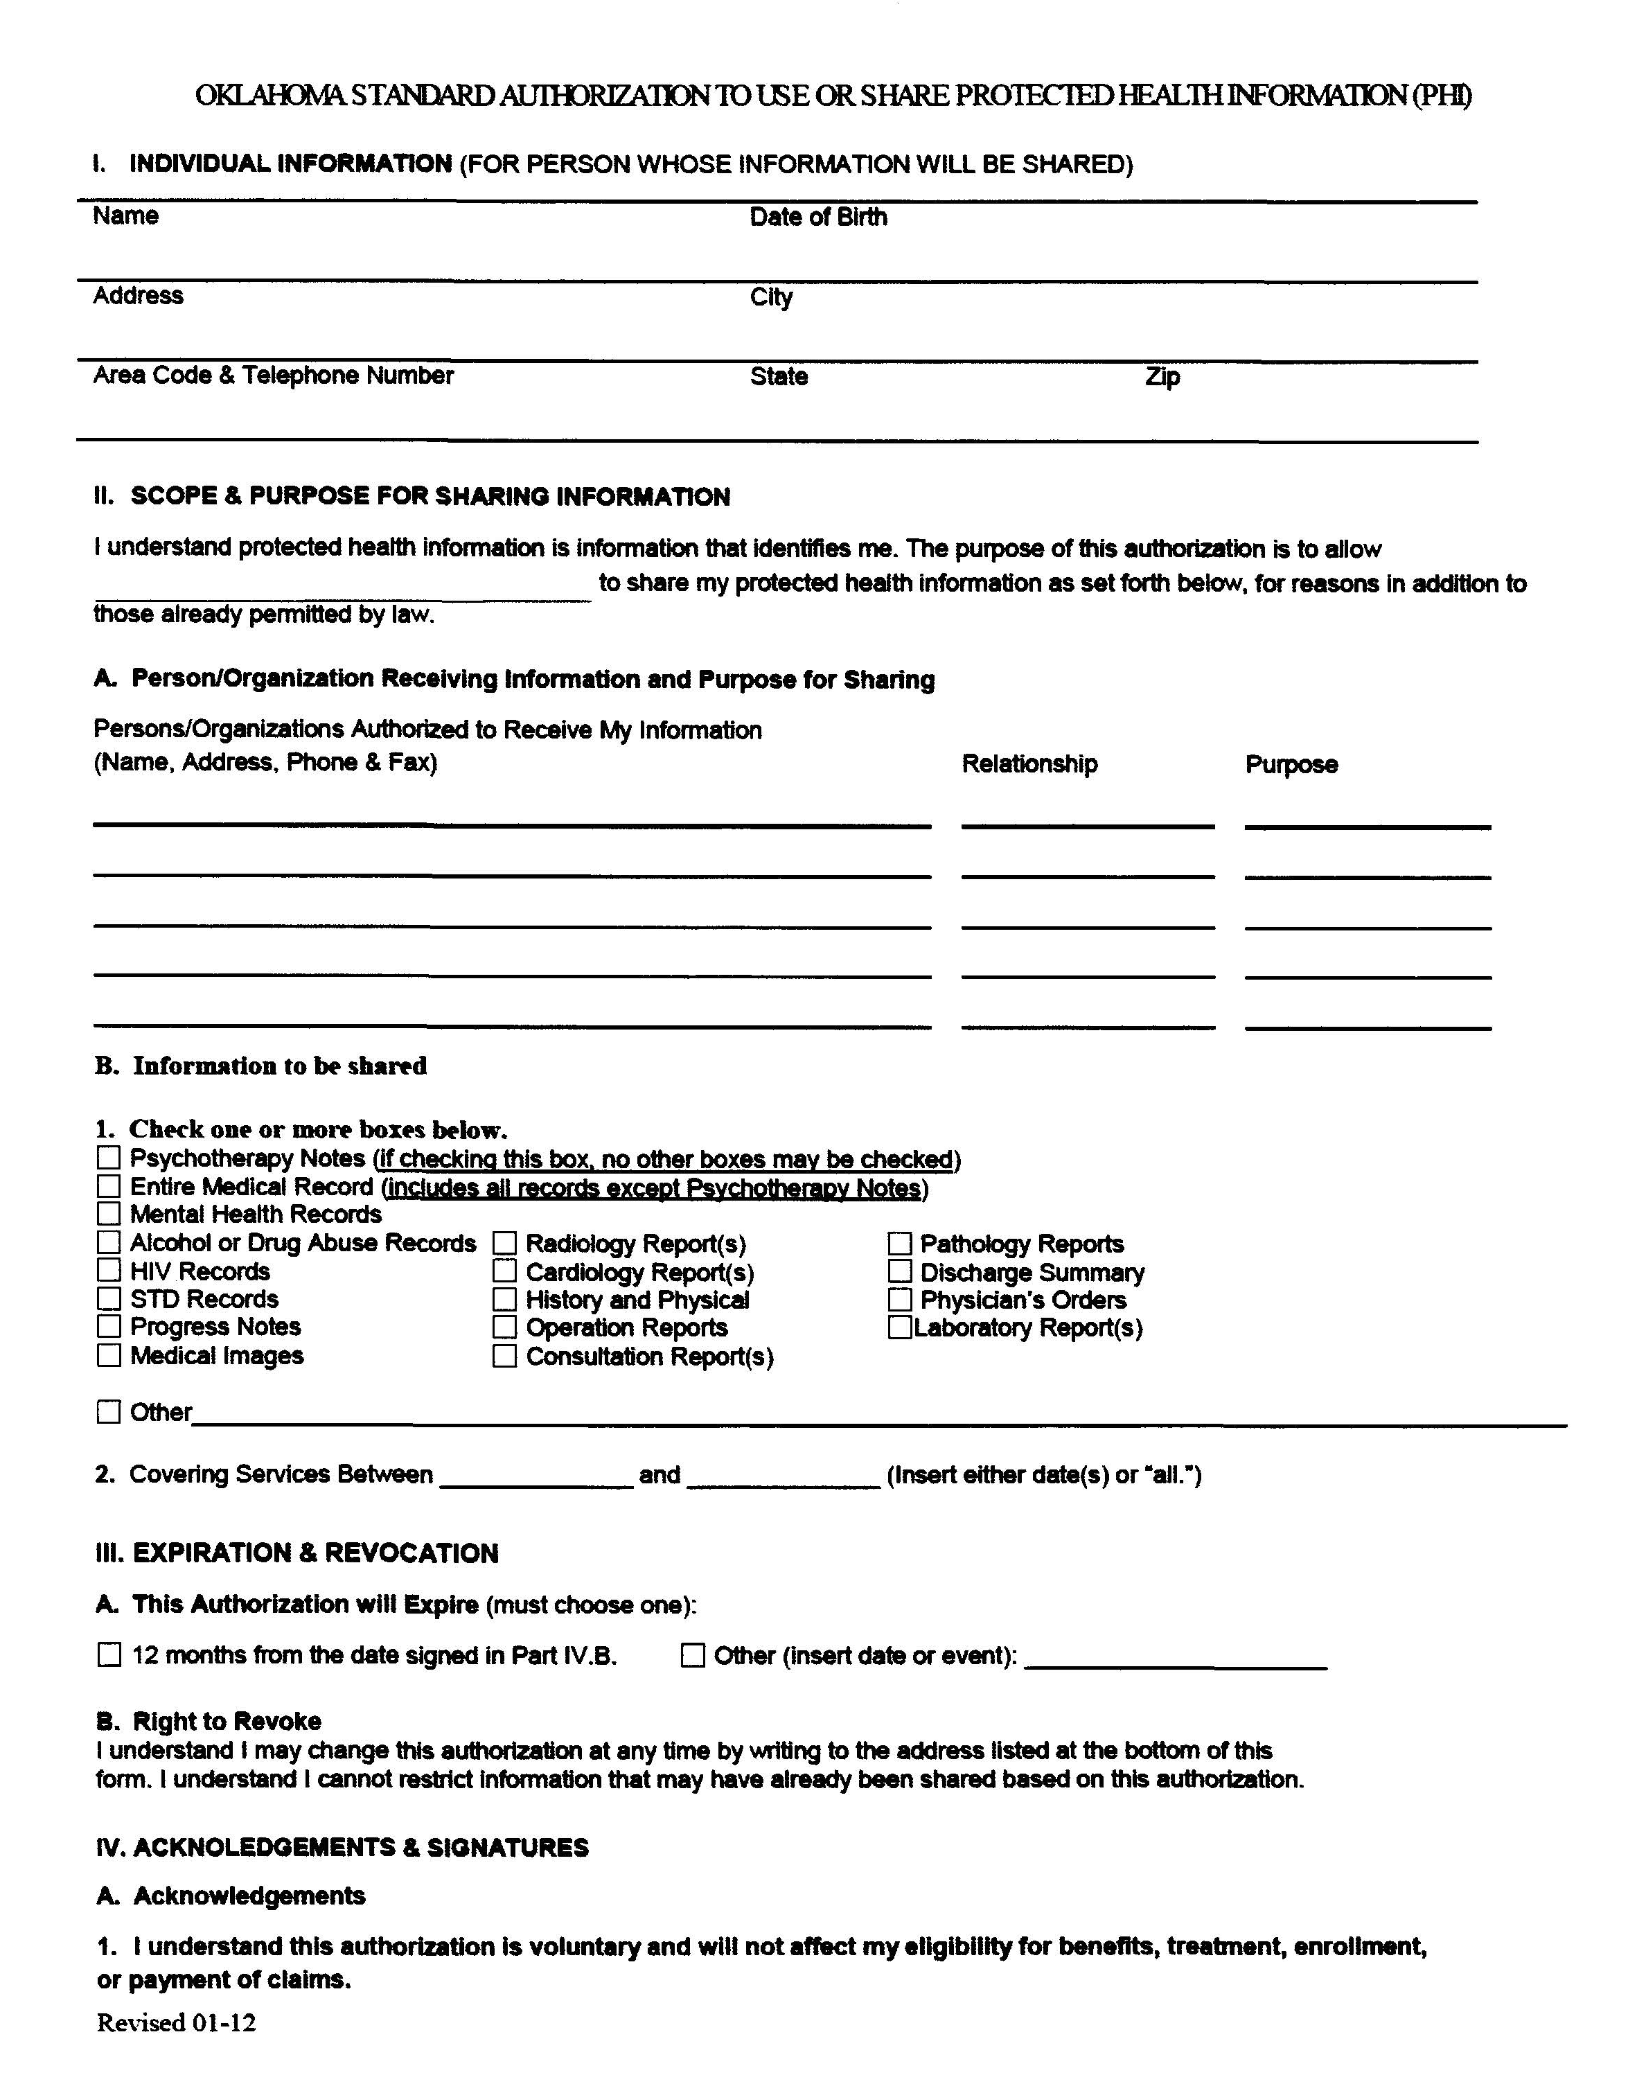
Order No. 01-28727-001 Pg 1 of 2
Louise Parham
06/09/1954

Genesys Family Health Center
Axiom Requisition Copy Service
2869 Jolly Rd
Okemos, MI 48864
Litigation/Discovery
Medical Records
X
X
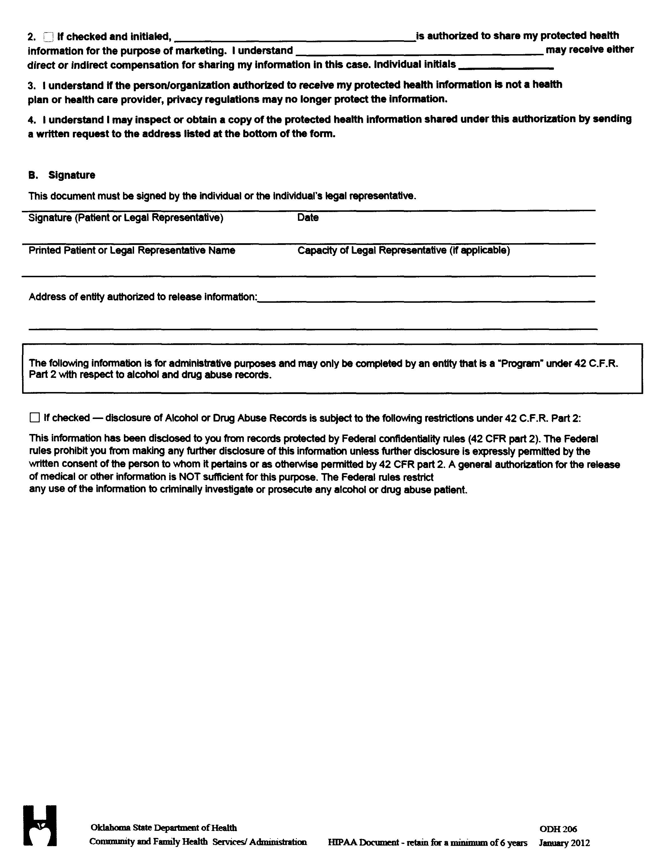
Order No. 01-28727-001 Pg 2 of 2

